Analyzing Memory States Using Java Management & Monitoring Tools

Version 1.0
13th February,2010

Copyright notice
Copyright © 2010, Cognizione consulting & solutions Pvt Ltd
All rights reserved.

These materials are confidential and proprietary to cognizione consulting & solutions pvt
ltd/its licensors and no part of these materials should be reproduced, published, transmitted
or distributed in any form or by any means, electronic, mechanical, photocopying, recording or
otherwise, or stored in any information storage or retrieval system of any nature nor should the
materials be disclosed to third parties without the prior express written authorization of
cognizione consulting & solutions Pvt ltd/its licensors

Revision history

Doc No: | Version no. | Change reference no. | Author | Published date | Sections changed | Description of changes
Tech_Java_01 | 1.0 |  | Dikshit Rajkhowa | 13th February,2010 |  | Base Document

Table of Contents

Introduction 4
Scope of the document 4
Target Audience 4
Technical Prerequisite 4
Software/Resources Required 5
The “jmap” tool 5
Creating snapshot of a memory heap using “jmap” 5
The “jhat” - Java Heap Analysis Tool 7
Diagnosing a memory heap snapshot using “jhat” 7

Introduction

A functionally perfect application seems to slow down after it runs continuously for several hours or after serving several client request. It may even become unresponsive or hang down requiring restarting of the whole application including the Application/Web Server. These situations are not uncommon in a typical production or even in a development environment.

Mostly these types of behavior are caused by memory leakages, deadlocks , inefficient uses of ‘finalizers’ etc. The difficult part is analyzing the root cause of these behavior. Java provides a host of management and monitoring tools out of the box to analyze such issues.

This document aims to introduce two such tools namely “jmap” and “jhat” that are primarily used to obtain a snapshot of the memory heap as well as analyzing it. These are very useful tools to analyze the memory status, total no of object instances etc at a particular point of time. Using the data provided the developer can have a fairly good idea about the unnecessary objects which may cause memory leakages and other memory related issues.

Scope of the document

This document only covers usage of the “jmap” and “jhat” tool on how to create and analyze a memory heap. This document doesn’t covers details on how to prevent memory leakages and other memory related issues as well as how to recover from a memory crash issues. These are very extensive topics and will be dealt in future documents.

This document only deals with the topic of creating and viewing snapshot of a memory heap. It doesn’t covers on how to analyze various parameters given by the dump file. It is planned to deal with such topics in future versions of this document.

This document should also not be taken as a complete reference to Java Management and Monitoring capabilities for complete monitoring of systems in production. This is a very huge topic and will be dealt in later versions.

Target Audience

This document is targeted basically for advanced developers and production support staff involved in analyzing and diagnosing memory issues.

Technical Prerequisite

This document is created with the assumption that the reader has a sound knowledge of the Java language (Core) and can compile and run Java programs using various command line options.

Software/Resources Required

Following software/resources are required to walkthrough the document

# | Software/Resources | Version
1 | JDK | 6

The “jmap” tool

jmap prints shared object memory maps or heap memory details of a given process or core file or a remote debug server.

The basic jmap command structure is given below

jmap [ option ] pid
jmap [ option ] executable core
jmap [ option ] [server-id@]remote-hostname-or-IP

Options are mutually exclusive. Option, if used, should follow immediately after the command name.

Creating snapshot of a memory heap using “jmap”

To create a snapshot of the memory heap using jmap the follow the steps described below
- Compile and run the following piece of code, which prints a statement 1000 times in an interval of 1 second.

class MemDumpTest
{
public static void main(String[] args)
{
for(int i = 0; i < 1000; i++)
{
System.out.println("\n Welcome to Java ");
try
{
Thread.sleep(1000);
}
catch (InterruptedException e)
{

}
}
}
}

- While the program is executing open a second command prompt in the same machine in which you are running the above code and type the following command

jps –l –m

( The jps command basically will give you the currently running processes in the JVM along with their process id)

- This should give you the output as shown below

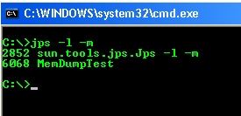

- From the above output we can find out that 6068 is the process id of our program i.e “MemDumpTest”

- Run the following command to take a snapshot of the heap in the same command prompt ( in which you run the “jps” command)

jmap -dump:format=b,file=Snapshot.map 6068

- As evident,6068 is the process id and Snapshot.map is the file in which the dump will be saved. “format = b” indicates that the file is saved in binary format. Executing the above command will produce a memory dump snapshot and will save it in the current folder. The output will be something as shown below
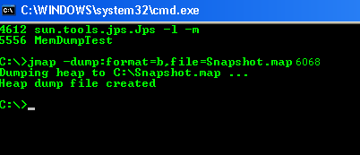

- Wait till the message “Heap dump file created” appears which indicates that the snapshot file is created successfully.

The “jhat” - Java Heap Analysis Tool

"jhat" - Java heap analysis tool or heap dump file browser is used to parses a Java heap dump file and to launch a Web server. "jhat" enables you to browse heap dump files using your favorite web browser. "jhat" supports pre-designed queries (such as 'show all instances of a known class "Foo"') as well as OQL (Object Query Language) - a SQL-like query language to query heap dumps.

Help on OQL is available from the OQL help page shown by "jhat". With the default port, OQL help is available at http://localhost:7000/oqlhelp/

Diagnosing a memory heap snapshot using “jhat”

Based on the snapshot created in the section - Creating snapshot of a memory heap using “jmap” we can browse the heap dump using jhat as described below

- CD to the directory in which the snapshot file is saved, and run the following command

jhat Snapshot.map

- This will produce the output as shown below

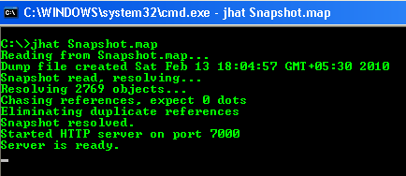

- Wait till the message “Server is ready” comes up which indicates that jhat server is ready to analyze the heap dump “Snapshot.map”

- Run a Web browser with http://localhost:7000. The "jhat" heap dump file server page shows up as shown below

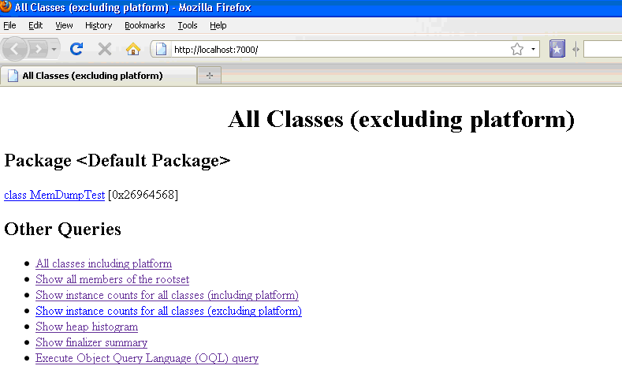

5) The above page gives statistical counts of loaded classes and objects. You can review object contents and references. You can also run object queries to search for any specific information. All these tasks can be done by navigating the various links.

The Road ahead

This document just touches the tip of a vast topic of managing java based applications using the Java Management and Monitoring Tools.

Further work on knowledge of application management needs to be done.

Some of the points that should be covered are

- Real time monitoring of memory status.
- Finding out various memory related issues that crops up during production along with their root causes.
- Handling such root causes.
- Recovering from system crashes due to memory leakages.
- Back up plan in case of system slowing down or crash.

